LAB NO: 7

**FUNDAMENTALS OF REACTJS**

**OBJECTIVE:** IMPLEMENT AND UNDERSTAND FUNDAMENTALS OF REACTJS.

**STUDENT TASK**

**Task 1: Set Up a New React Project**

**1.** Use **npm create vite@latest** to create a new React project.

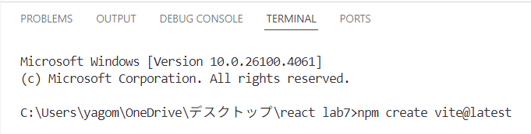

**2.** Name the project with **your_Name_Roll_Number (i.e. Yagome Hina 305) .**

**3.** Open the project in **VS Code.**

4. Create a React app with **headings, paragraphs,** and a **button**, then style it using **index.css.**

* **BONUS (OPTIONAL):**

Try to use **Bootstrap 5** for styling.

* **BOOTSTRAP INSTALLATION:**

**App.jsx:**

**Index.css:**

* A screenshot of a computer

  AI-generated content may be incorrect.**OUTPUT:**

***LAB 7 SUMMARY: REACT APP SETUP AND BASICS WHAT I LEARN :***

1. **React Project Setup**

* Used npm create vite@latest to create a new React project with Vite.
  + Named the project using the format Name_Roll_Number.

1. **Using the Command Line**
   * Navigated folders using cd
   * Installed dependencies with npm install
   * Started the development server using npm run dev
2. **Basic React App Development**
   * Built a simple app with headings, paragraphs, and a clickable button.
   * Learned to handle basic user interaction in React.
3. **Styling with CSS**
   * Styled the app using index.css to change layout, fonts, colors, etc.
4. **(Optional) Bootstrap Integration**
   * Applied Bootstrap 5 classes to improve design and layout quickly.